How to Add a Course in CITI

Instructions: If you have already completed the GCP for Clinical Trials with Investigational Drugs, Biologics, and Devices – Basic Course, you may enroll in the Refresher Course, which now includes updated E6(R3) guidance.
If you completed the Refresher Course before the E6(R3) updates were added to the training materials, you may also take the “ICH GCP E6(R3): An Introduction” course.
Steps for adding these courses to your Active Courses list in CITI are provided below. Adding these courses will not expire your existing CITI training in the UNC Training Database; the new course will simply be added to your completion list.
For questions or concerns, please contact OneUNCClinRes@unc.edu.

- Go to https://www.citiprogram.org/
- Log in with your CITI credentials.
- On the Welcome screen, select “View Courses.”


- At the bottom of the next page, select “Add a Course.”
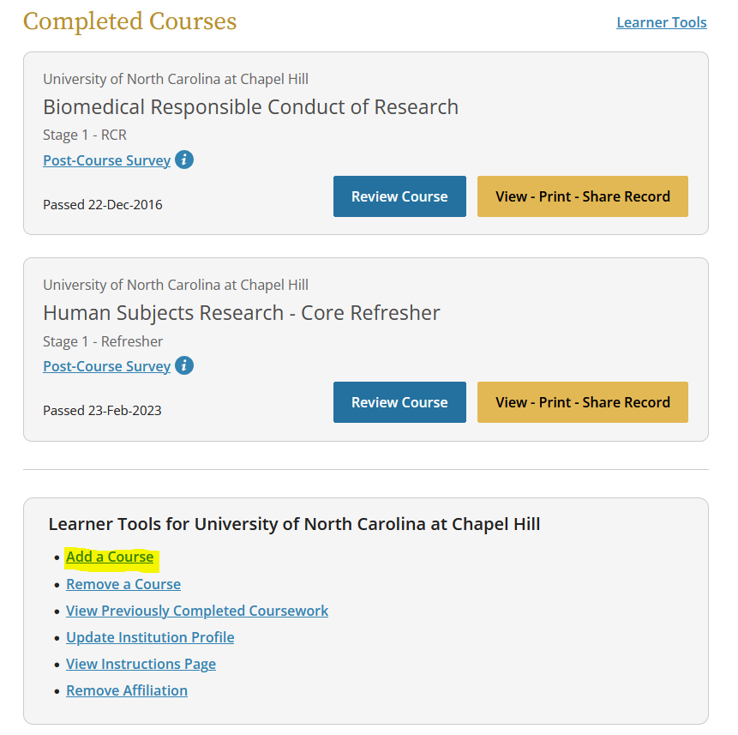

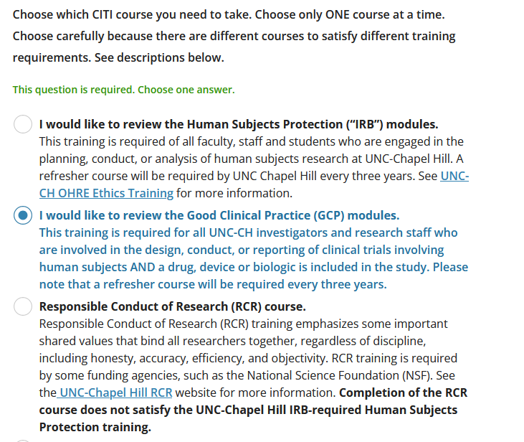
- Scroll down and choose “I would like to review the Good Clinical Practice (GCP) modules.”
- At the bottom of the page, click “Next.”

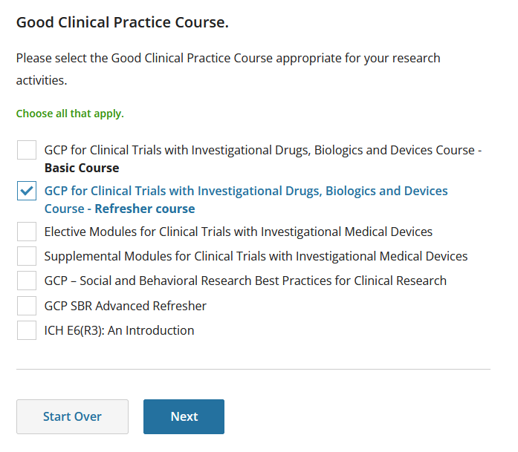
- Select “GCP for Clinical Trials with Investigational Drugs, Biologics and Devices Course – Refresher Course OR ICH E6(R3): An Introduction”

- Click “Next.”

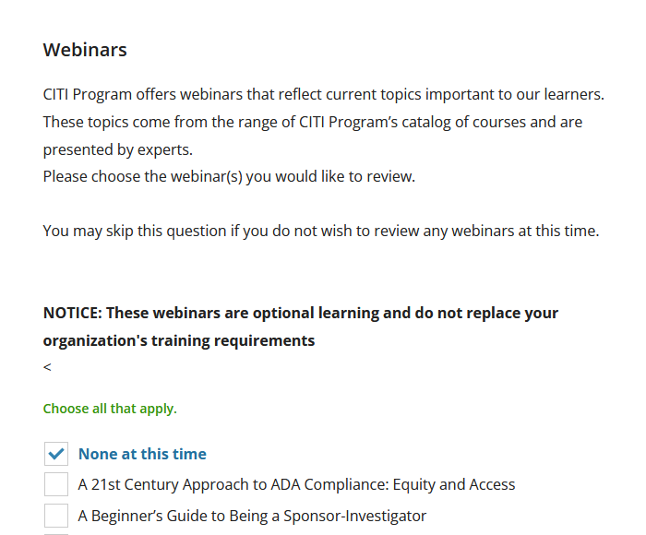
- On the following screen, either select “None at this time” or choose any webinars that interest you.

- Click “Next.”


- You should now see a green confirmation message.

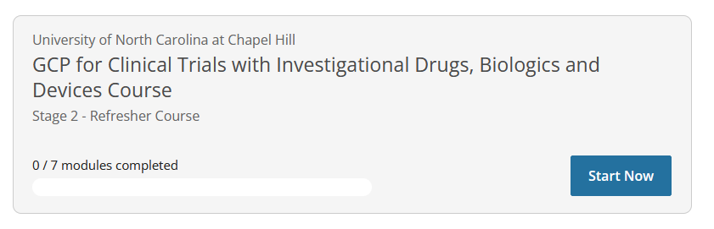
- Scroll to the bottom of your Active Courses list to find your newly added course.

